PepeFit

Change Management Report

# Introduction

The purpose of this document is to provide a better view of how we are going to handle the changes we are going to make on the PepeFit Project.

# Change Management Process

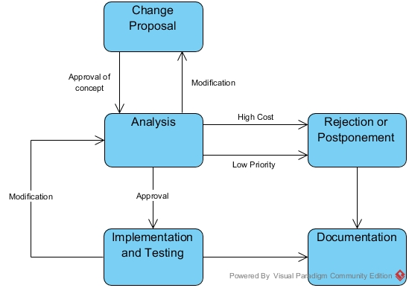

We have weekly meetings to discuss what we’ve learned, what we’ve done, what is next to do and what can be done to further improve our project. Beside our meetings we keep in-touch using Asana.

Most of the proposals and feedbacks are given during those meetings and on Asana platform. We discuss those proposals and if the proposal sounds good the project manager assigns its analysis to the related person. Then we discuss the analysis and decide to make the change/implement the feature or not. If we decide to make the change/implement the feature the project manager assigns the task to the suited member.

Whether the proposals end up rejected, postponed or accepted we write all of them down to avoid proposing same ideas in the future and to use them as a step to come up with better ideas. Our configuration manager is responsible for handling these documents.

We use GitHub to manage our project. GitHub makes it easier to see the changes that’ve been made on a file and who’s made those changes. It also provides easy access to previous versions so we can roll back to previous versions if we encounter a problem or we can simply use them for testing.

# Proposals

All project members (especially frontend and backend developers of the same pages) try to be in contact as much as possible. Due to this our project is open to change during the whole development process and usually undergoes many small scale changes right at the development stage.  
  
Some changes, however, may require and in-depth analysis of the change and can only be applied after understanding what else has to change for it, for how long it’ll delay the development and how vital it is for the project.

Our most significant proposals can be seen in the table below.

|  |  |  |  |  |  |
| --- | --- | --- | --- | --- | --- |
| **Proposal** | **State** | **Priority** | **Date** | **Details** | **Reason** |
| *Detailed progress report* | *Postponed* | *Low* | *23/03/18* | *A more detailed pdf report for users to download from their user page.* | *Low priority* |
| *Gold user account* | *Rejected* | *Low* | *23/03/18* | *Gold users will be able train at any gym station.* | *High cost of time & effort Low priority* |
| *Using Maven* | *Accepted* | *Normal* | *23/03/18* | *Maven is a build management tool that will make easier for multiple people to work on a project* | *Lowers time cost* |
| *Using GitHub branches* | *Accepted* | *High* | *18/04/18* | *Having each project member work on a separate branch will allow them to move more freely and will allow them to experiment with more drastic changes* | *Makes testing, supervising and development easier, lowers time cost, increases product quality* |
| *Course pages code design change* | *Accepted* | *High* | *01/05/18* | *Having separate divisions for each course will make development significantly easier* | *Increases development efficiency, increases product quality* |
| *Superadmin Account* | *Accepted* | *Normal* | *04/05/18* | *Having a special developer-only account that can access every page & function will increase the development speed* | *Lowers time cost and increases efficiency* |

|  |  |  |  |  |  |
| --- | --- | --- | --- | --- | --- |
| **Proposal** | **State** | **Priority** | **Date** | **Details** | **Reason** |
| *Postponement of achievement system* | *Accepted* | *Normal* | *11/05/18* | *The system which trainers would assign achievement badges to members and members to be able to view their badges on their profiles* | *Low priority* |
| *Postponement of settings page* | *Accepted* | *Normal* | *11/05/18* | *A page where users can change their emails and passwords* | *Low priority* |
| *Allocating resources to find a solution for the long course pages loading time* | *Accepted* | *High* | *11/05/18* | *<c:forEach> tag calls the function at every loop, unnecessarily increasing the loading time.* | *Lowers development time cost, increases user experience* |
| *Making the selected/added courses default page* | *Accepted* | *High* | *13/05/18* | *Getting rid of the empty, placeholder division and replacing it with added/registered courses will allow users to track their courses with less clicks* | *Increases user experience* |